# Big Data Hadoop Training

Project: State-wise Development Analysis Solution

**1. Executive Summary**

**1.1 Project Overview**

To develop the System to analyze the log data (In XML format) of government progress of various development activities.

**1.2 Purpose and Scope of this Specification**

The purpose of this project is to capture the data for analyzing the progress of various activities.

**In scope**

This following requirement will be addressed in phase 1 of Project:

* Developing system to handle the incoming log feed and store the information in Hadoop Cluster(Flume)
* Analyze the data and understand the progress
* Store the results in hbase/RDBMS

**2. Product/Service Description**

**2.1 Assumptions**

Log will be generated in XML format and stored in a server

**2.2 Constraints**

Describe any items that will constrain the design options, including

* This system may not be used for searching for now. But it will be used for analysis and saving the relevant information as of now
* System will be using mysql as a database

**3. Requirements**

* The FLUME job which will place format the data and place the data to HDFS
* Pig/Mapreduce job for parsing the XML data.
* Create pig scripts/Mapreduce jobs to analyze the data
* Create the sqoop job to store the data in database

**Priority Definitions**

The following definitions are intended as a guideline to prioritize requirements.

Priority 1 – Create FLUME job for fetching log files from spool directory into HDFS

Priority 2 – Mapreduce/pig job to preprocess

**Download the dataset using the below link:**

**Link:** <https://drive.google.com/file/d/0Bxr27gVaXO5sUjd2RWFQS3hQQUE/view?usp=sharing>

Data kept in **/My_Downloads/Assignments_BDH/State_wise_Dev_Analysis_India local FS**

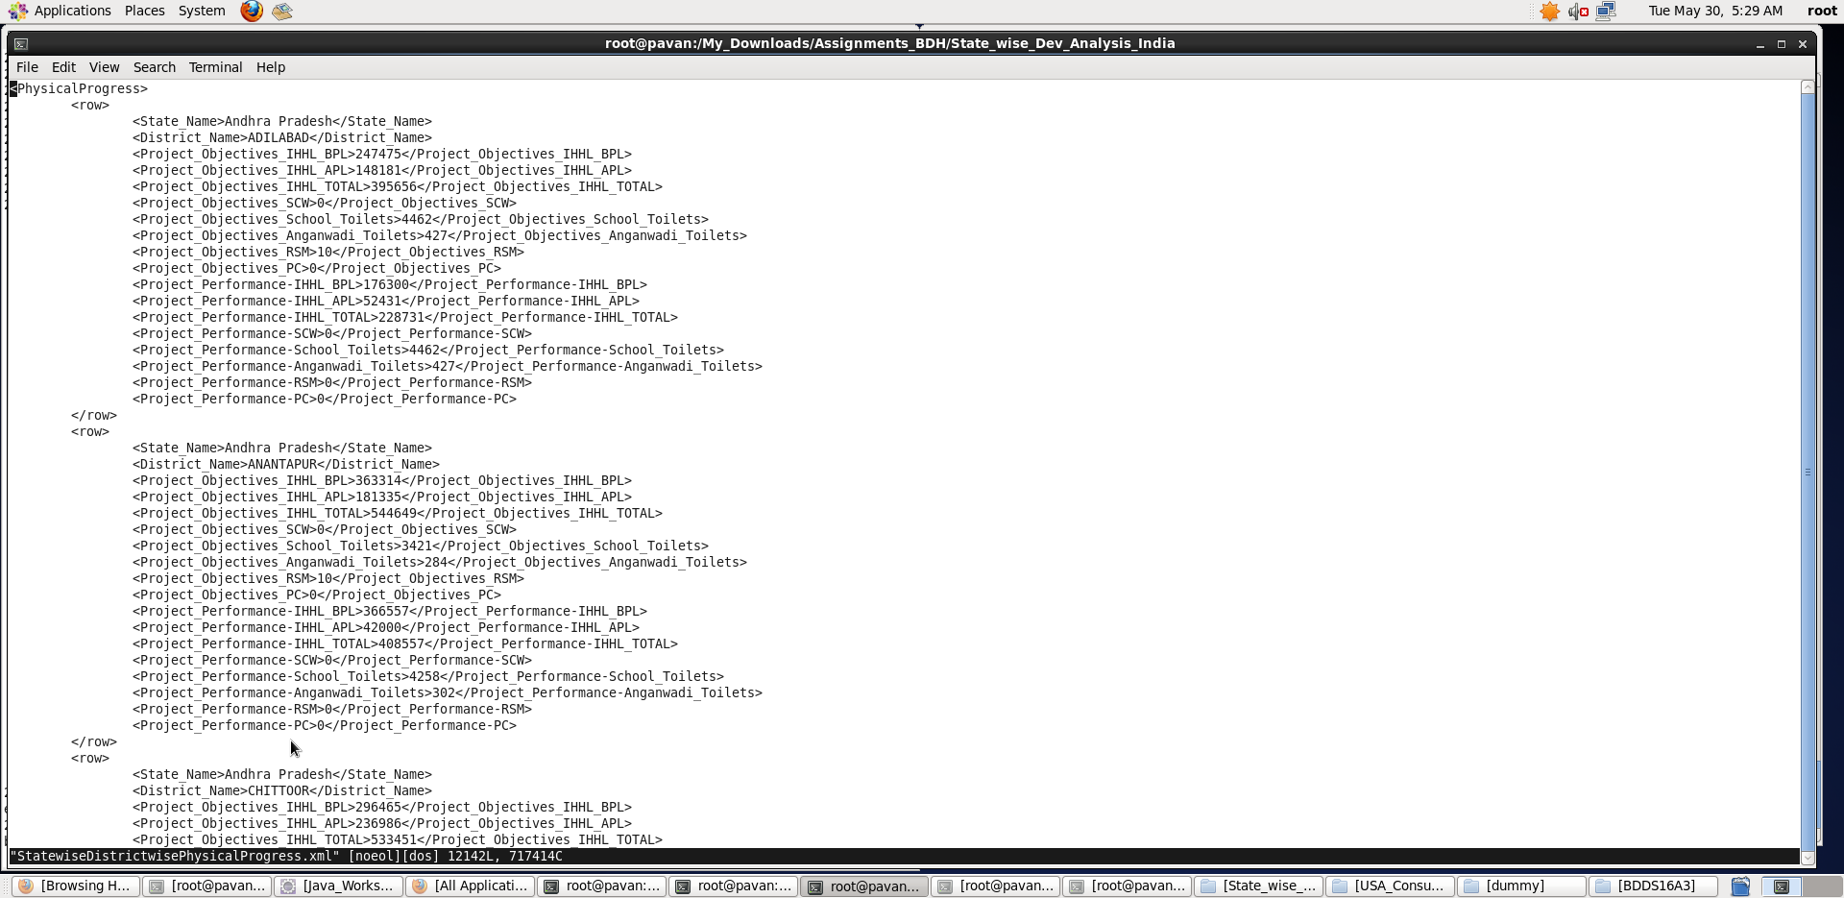

**Steps followed to create the above project.**

**Step 1:**

**Copy dataset from local file system to HDFS using flume.**

1. We will be using spool directory as our source and HDFS as destination.  
   Here we will create an agent for flume (here data is fetched from Local File System).

**Flume_data_transfer_State_Dev_Analysis.conf file: (put it in /etc/flume-ng/conf directory)**

#Flume Configuration Starts

dev_analysis.sources = localsrc

dev_analysis.channels = fileChannel

dev_analysis.sinks = hdfsdest

# Define a source for dev_analysis on linux FS

dev_analysis.sources.localsrc.type = spooldir

#Spooldir in my case is /My_Downloads/Assignments_BDH/State_wise_Dev_Analysis_India

dev_analysis.sources.localsrc.spoolDir = /My_Downloads/Assignments_BDH/State_wise_Dev_Analysis_India

dev_analysis.sources.localsrc.fileHeader = false

dev_analysis.sources.localsrc.fileSuffix = .COMPLETED

# Define a file channel called fileChannel on dev_analysis on linux FS

dev_analysis.channels.fileChannel.type = memory

dev_analysis.channels.fileChannel.capacity = 200000

dev_analysis.channels.fileChannel.transactionCapacity = 1000

# Define a sink for dev_analysis on HDFS

dev_analysis.sinks.hdfsdest.type = hdfs

#Sink is /tmp/State_wise_Dev_Analysis_India/flume_import under hdfs

dev_analysis.sinks.hdfsdest.hdfs.path = hdfs://pavan:8020/tmp/State_wise_Dev_Analysis_India/flume_import

dev_analysis.sinks.hdfsdest.hdfs.batchSize = 1000

dev_analysis.sinks.hdfsdest.hdfs.rollSize = 268435456

dev_analysis.sinks.hdfsdest.hdfs.rollInterval = 0

dev_analysis.sinks.hdfsdest.hdfs.rollCount = 50000000

dev_analysis.sinks.hdfsdest.hdfs.writeFormat=Text

dev_analysis.sinks.hdfsdest.hdfs.fileType = DataStream

# Associating Channel with both Source and Sink

dev_analysis.sources.localsrc.channels = fileChannel

dev_analysis.sinks.hdfsdest.channel = fileChannel

Note: This is a basic conf file configuring the source, channel and sink.

**dev_analysis** is the flume agent name

1) dev_analysis.sources.source1_1.spoolDir is set with input path as in local file system path.

Here <input_path> is < /My_Downloads/Assignments_BDH/State_wise_Dev_Analysis_India>

2) dev_analysis.sinks.hdfs-sink1_1.hdfs.path is set with output path as in HDFS path

Here <output_path> is <hdfs://pavan:8020/tmp/State_wise_Dev_Analysis_India/flume_import>

Note: Hostname : pavan , PortNo: 8020 to connect to my HDFS.

**Create specified input and output paths and give read/write permissions accordingly.**

**We will now open another terminal and start flume agent by the following**

**Command:**

flume-ng agent --name dev_analysis --conf-file /etc/flume-ng/conf/flume_data_transfer_State_Dev_Analysis.conf

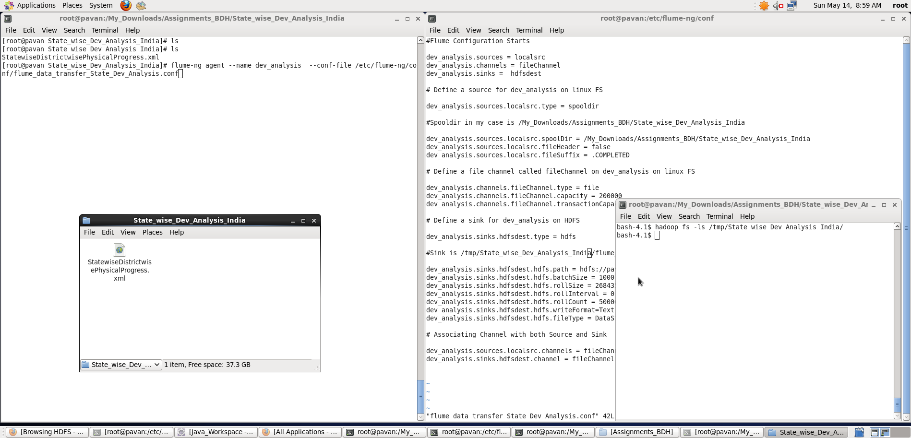

**Once the flume starts running, the dataset we placed in the SpoolDir gets copied into HDFS.**

**Once, the copying is done, it marks the input files as .COMPLETED (we specified in flume_data_transfer_State_wise_Dev_Analysis.conf file)**

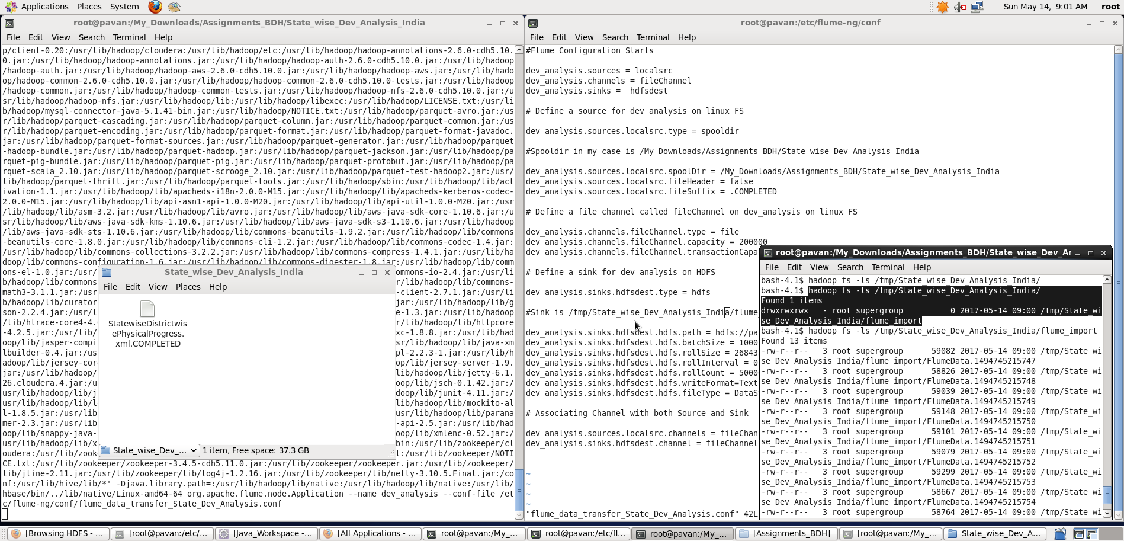

**We can see the dataset being copied into specified sink directory in HDFS using the command:**

**$ hadoop fs –cat /tmp/State_wise_Dev_Analysis/flume_import/FlumeData.1494745215759**

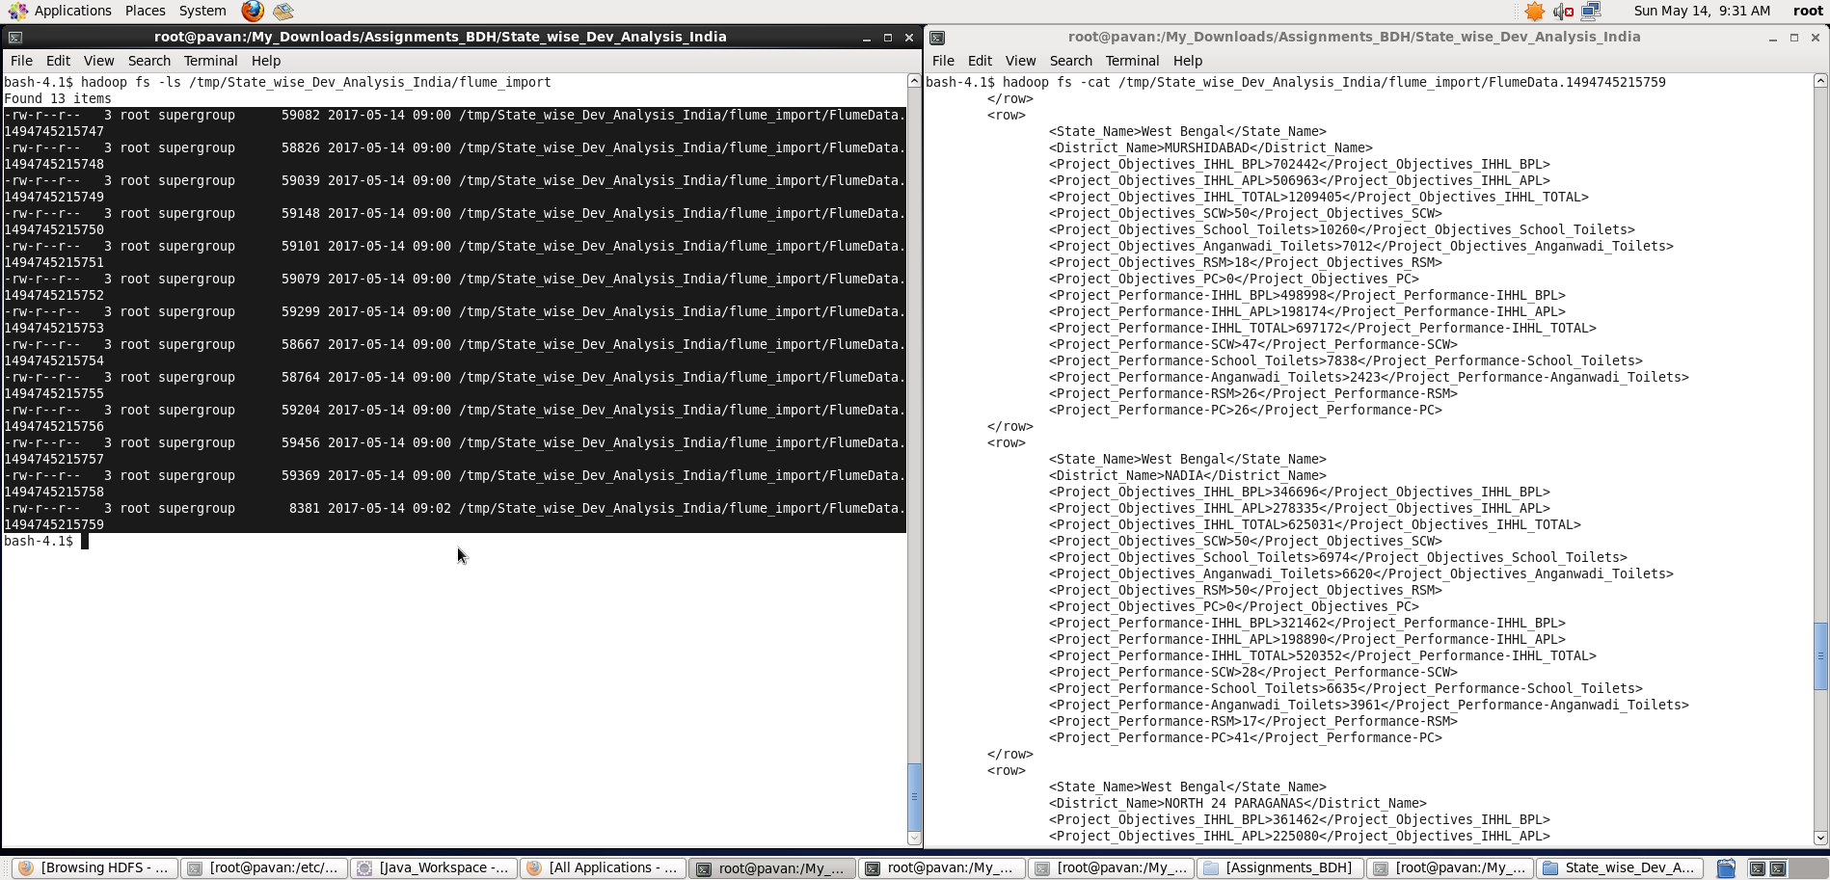

**Now, we work on problem statements in which I am loading the data from HDFS.**

**Step 2:** Input file is in the XML format use Map reduce or pig to parse the data and get the results for the below problem statements.

**Note: I have used Pig Scripts to get the results for the below problem statements.**

**Problem statement 1:**

1. Find out the districts who achieved 100 percent objective in BPL cards

A. **Pig Latin Script:**

register '/usr/lib/pig/piggybank.jar';

xmldata_from_hdfs = LOAD 'hdfs://pavan:8020/tmp/State_wise_Dev_Analysis_India/flume_import/' using org.apache.pig.piggybank.storage.XMLLoader('row') as (doc:chararray);

xmldata_parsed = foreach xmldata_from_hdfs GENERATE FLATTEN(REGEX_EXTRACT_ALL(doc,'<row>\\s*<State_Name>(.*)</State_Name>\\s*<District_Name>(.*)</District_Name>\\s*<Project_Objectives_IHHL_BPL>(.*)</Project_Objectives_IHHL_BPL>\\s*<Project_Objectives_IHHL_APL>(.*)</Project_Objectives_IHHL_APL>\\s*<Project_Objectives_IHHL_TOTAL>(.*)</Project_Objectives_IHHL_TOTAL>\\s*<Project_Objectives_SCW>(.*)</Project_Objectives_SCW>\\s*<Project_Objectives_School_Toilets>(.*)</Project_Objectives_School_Toilets>\\s*<Project_Objectives_Anganwadi_Toilets>(.*)</Project_Objectives_Anganwadi_Toilets>\\s*<Project_Objectives_RSM>(.*)</Project_Objectives_RSM>\\s*<Project_Objectives_PC>(.*)</Project_Objectives_PC>\\s*<Project_Performance-IHHL_BPL>(.*)</Project_Performance-IHHL_BPL>\\s*<Project_Performance-IHHL_APL>(.*)</Project_Performance-IHHL_APL>\\s*<Project_Performance-IHHL_TOTAL>(.*)</Project_Performance-IHHL_TOTAL>\\s*<Project_Performance-SCW>(.*)</Project_Performance-SCW>\\s*<Project_Performance-School_Toilets>(.*)</Project_Performance-School_Toilets>\\s*<Project_Performance-Anganwadi_Toilets>(.*)</Project_Performance-Anganwadi_Toilets>\\s*<Project_Performance-RSM>(.*)</Project_Performance-RSM>\\s*<Project_Performance-PC>(.*)</Project_Performance-PC>\\s*</row>')) AS (state_name:chararray, district_name:chararray, po_ihhl_bpl:int, po_ihhl_apl:int, po_ihhl_total:int, po_scw:int, po_sch_toilets:int, po_angan_toilets:int, po_rsm:int, po_pc:int, pp_ihhl_bpl:int, pp_ihhl_apl:int, pp_ihhl_total:int, pp_scw:int, pp_sch_toilets:int, pp_angan_toilets:int, pp_rsm:int, pp_pc:int);

data_with_full_percent_bpl_cards = filter xmldata_parsed by po_ihhl_bpl==pp_ihhl_bpl;

districts_with_full_percent_bpl_cards = foreach data_with_full_percent_bpl_cards generate district_name,po_ihhl_bpl,pp_ihhl_bpl;

--dump districts_with_full_percent_bpl_cards;

store districts_with_full_percent_bpl_cards into 'hdfs://pavan:8020/tmp/project_2/State_wise_Dev_Analysis_results' using PigStorage (',');

**Explanation :**

* Loaded data from HDFS directory location: **'hdfs://pavan:8020/tmp/State_wise_Dev_Analysis_India/flume_import/'** into “xmldata_from_hdfs” relation using XMLLoader and schema is provided accordingly.

**Note: In order to load the XML data into the Pig structures, one needs to parse the XML so that Pig can understand it. Thus we shall use the XMLLoader() function which is present in PiggyBank of Apache. PiggyBank is a repository of Java user defined functions.**

* Then, all records are filtered based on 100 percent objective in BPL cards i.e. (po_ihl_bpl==pp_ihhl_bpl)
* Now, foreach data_with_full_percent_bpl_cards , I have generated the district_name, po_ihhl_bpl and pp_ihhl_bpl records.
* **Storing the result relation into a HDFS directory** 'hdfs://pavan:8020/tmp/project_2/State_wise_Dev_Analysis_results’**.**

Screenshots

Running **Pig Latin Script in Local Mode** inside /My_Downloads/Assignments_BDH/State_wise_Dev_Analysis_India/ directory

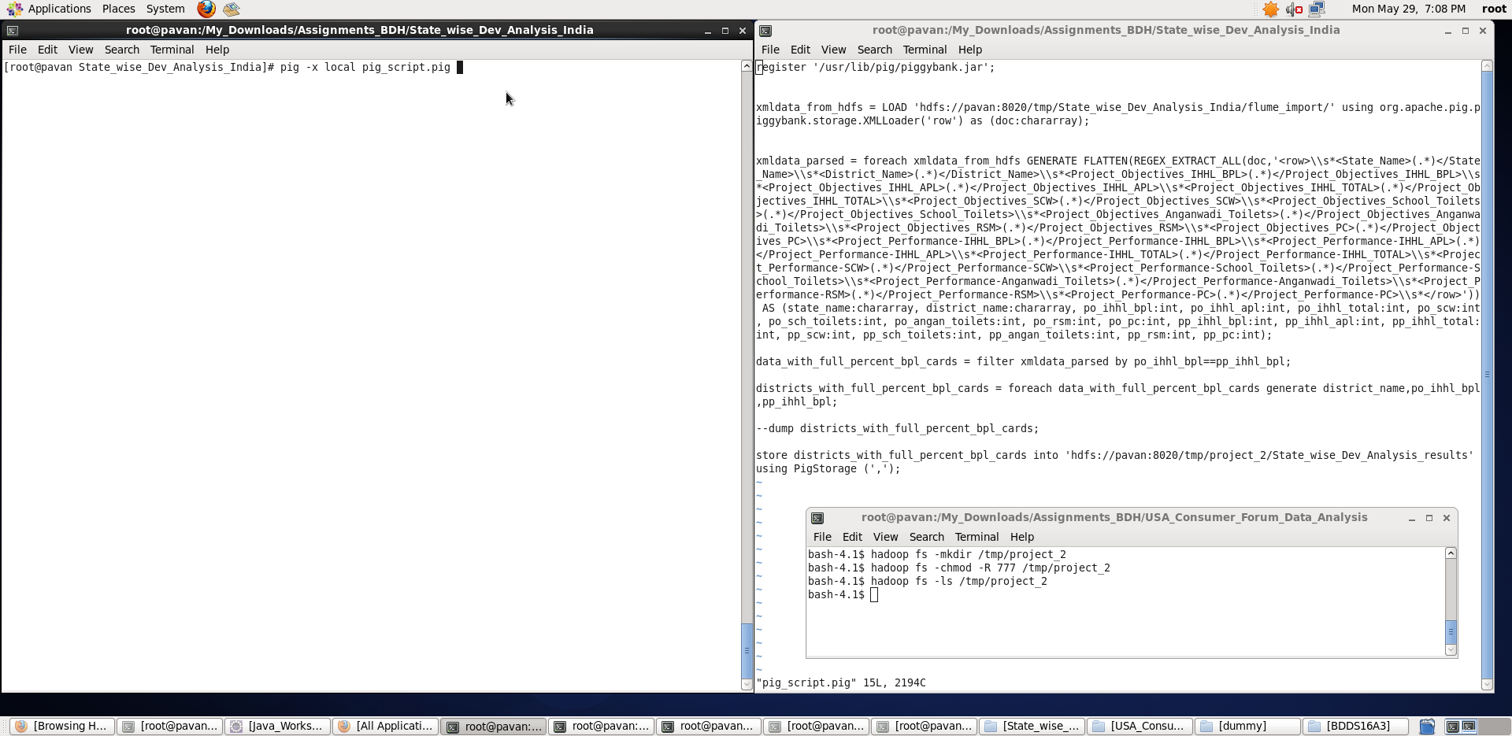

**Output stored in the format**: **<District_Name>,<po_ihhl_bpl>,<pp_ihhl_bpl>**

**We can see the output stored in the specified HDFS directory as below:**

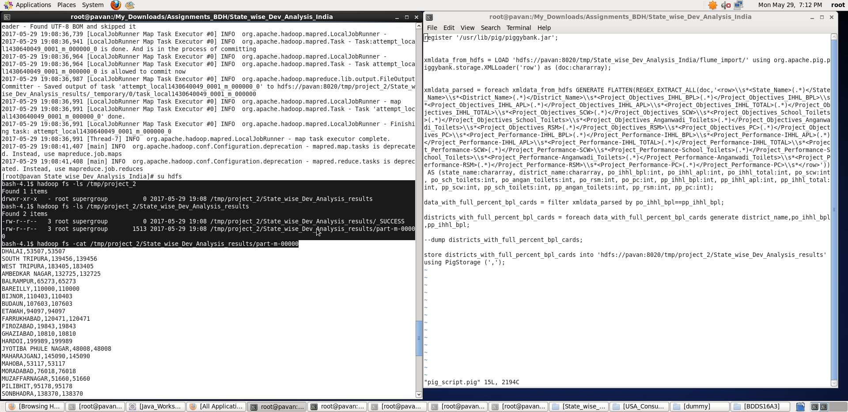

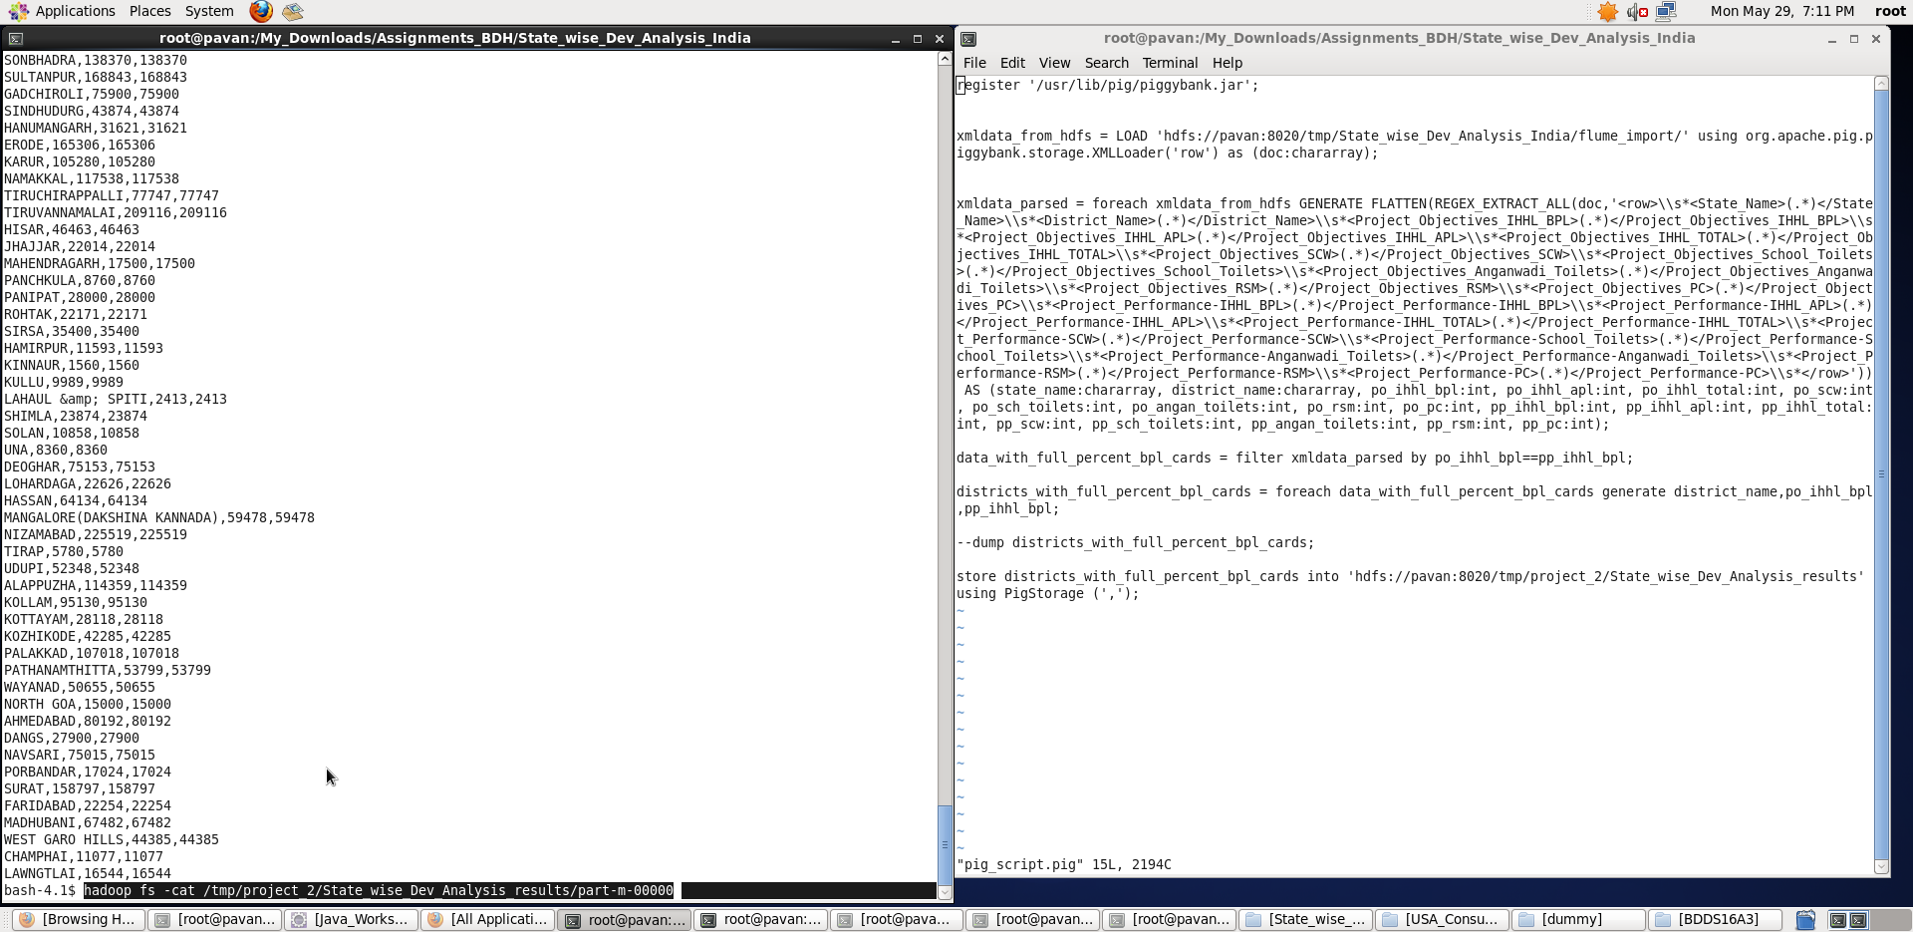

**Export the results to mysql using sqoop :**

**For this, the table should be already present in mysql before we export the result from HDFS**

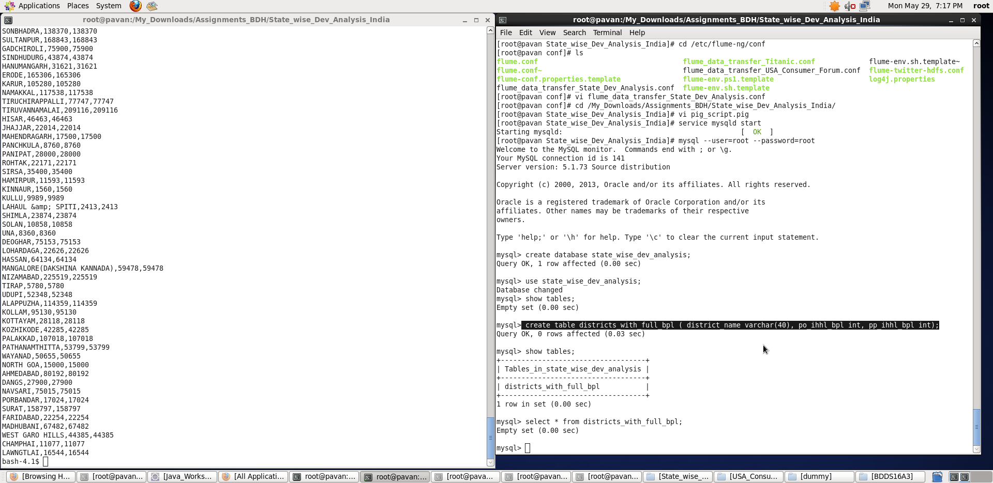

**Once, the table is created, use the sqoop export command as shown below to export the results into mysql.**

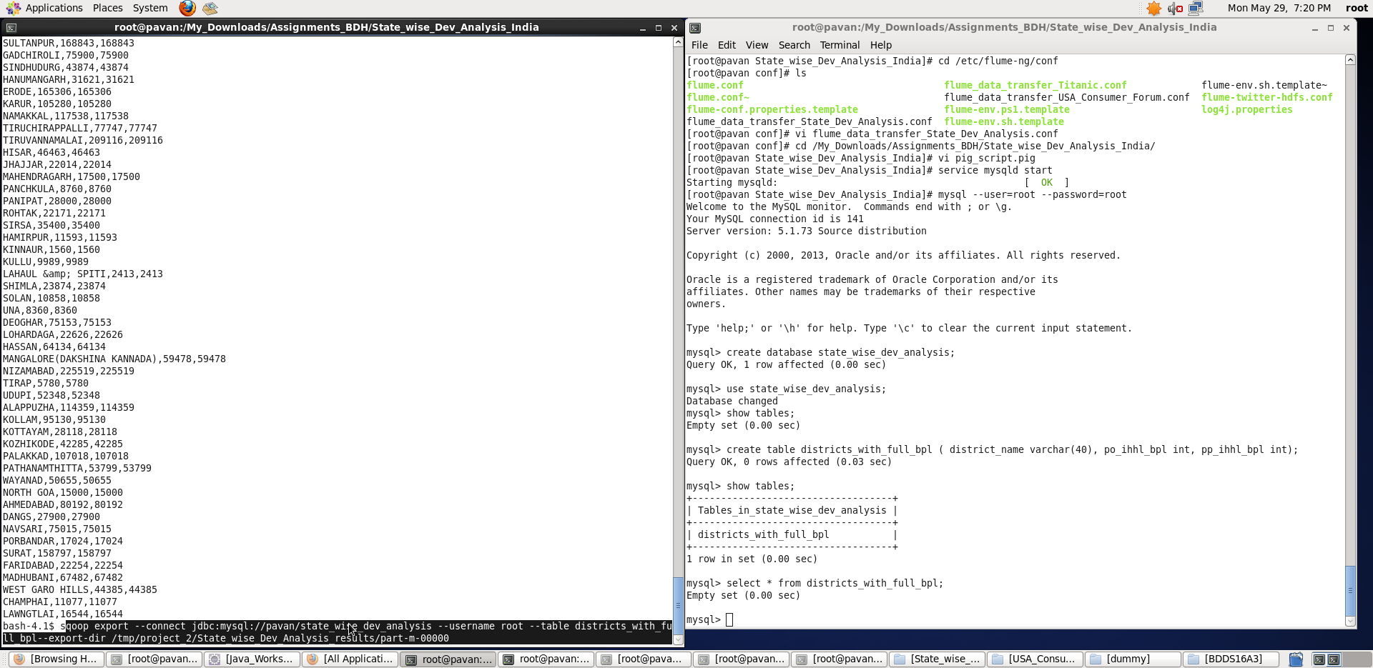

**Once, the export is done, we can see results getting stored in the districts_with_full_bpl table inside state_wise_dev_analysis database using “*select * from districts_with_full_bpl”* command.**

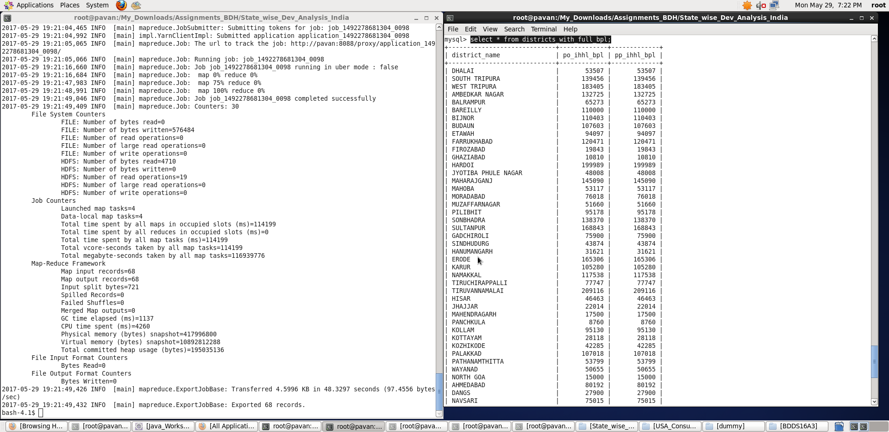

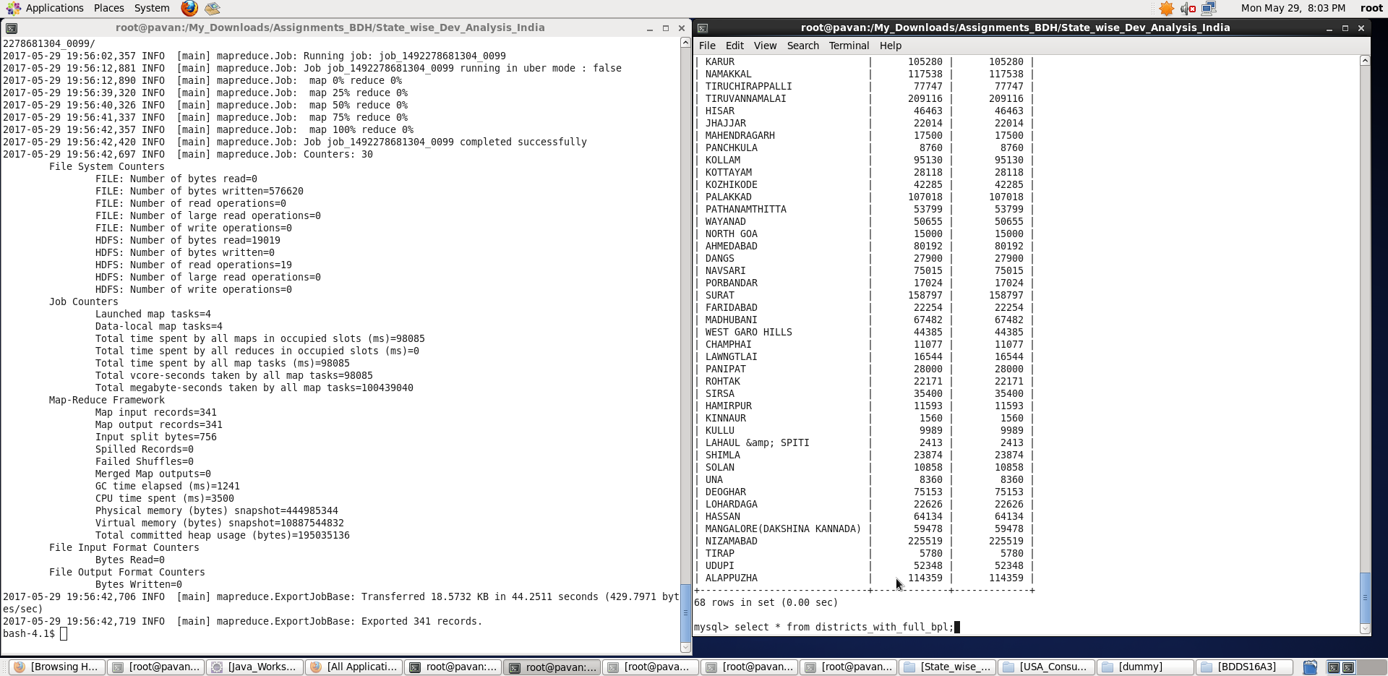

**Thus, we found the districts who achieved 100 percent objective in BPL cards and exported the results to mysql using sqoop.**

**Note: I have considered exact 100 percent objective achievement in BPL cards**

**Problem statement 2:**

2. Write a Pig UDF to filter the districts who have reached 80% of objectives of BPL cards.

1. **Steps involved in writing a Pig UDF:**
2. Create Java Class for a User Defined Function which extends org.apache.pig.FilterFunc.

**Java code:**

import java.io.IOException;

import org.apache.pig.FilterFunc;

import org.apache.pig.data.Tuple;

public class pig_udf_filter_districts extends FilterFunc {

@Override

public Boolean exec(Tuple input) throws IOException {

// TODO Auto-generated method stub

try {

int po_ihhl_bpl = Integer.parseInt(input.get(0).toString());

int pp_ihhl_bpl = Integer.parseInt(input.get(1).toString());

if (pp_ihhl_bpl >= (0.8)*po_ihhl_bpl)

return true;

else

return false;

}

catch(ArrayIndexOutOfBoundsException e){

System.out.println("FAILED: SemanticException : Arguments length mismatch");

System.out.println("Input Tuple should consist of two arguments");

}

return null;

}

}

1. Packaging the Java class into a JAR file (I am using Maven)

Make the folder structure pig_udf/src/main/java/pig_udf_filter_districts.java. Place the pom.xml file in pig_udf/ and run the maven build command

**# mvn clean install**

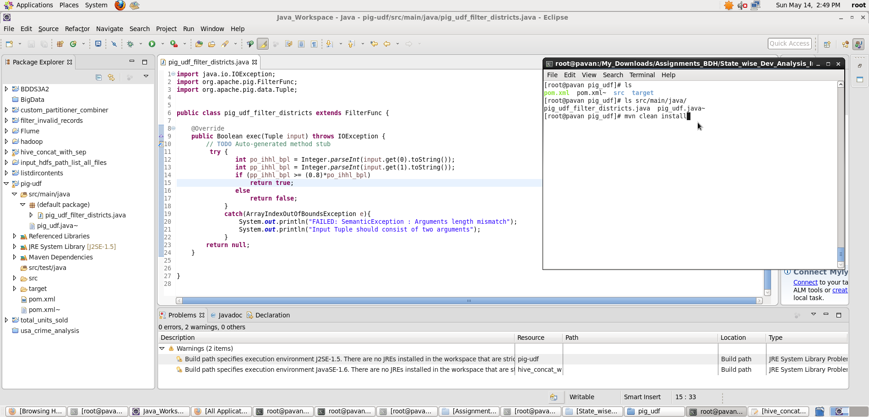

Once, the build is successful, we can see the **pig_udf_filter_districts_on_BPL_cards.jar** being created inside the target directory.

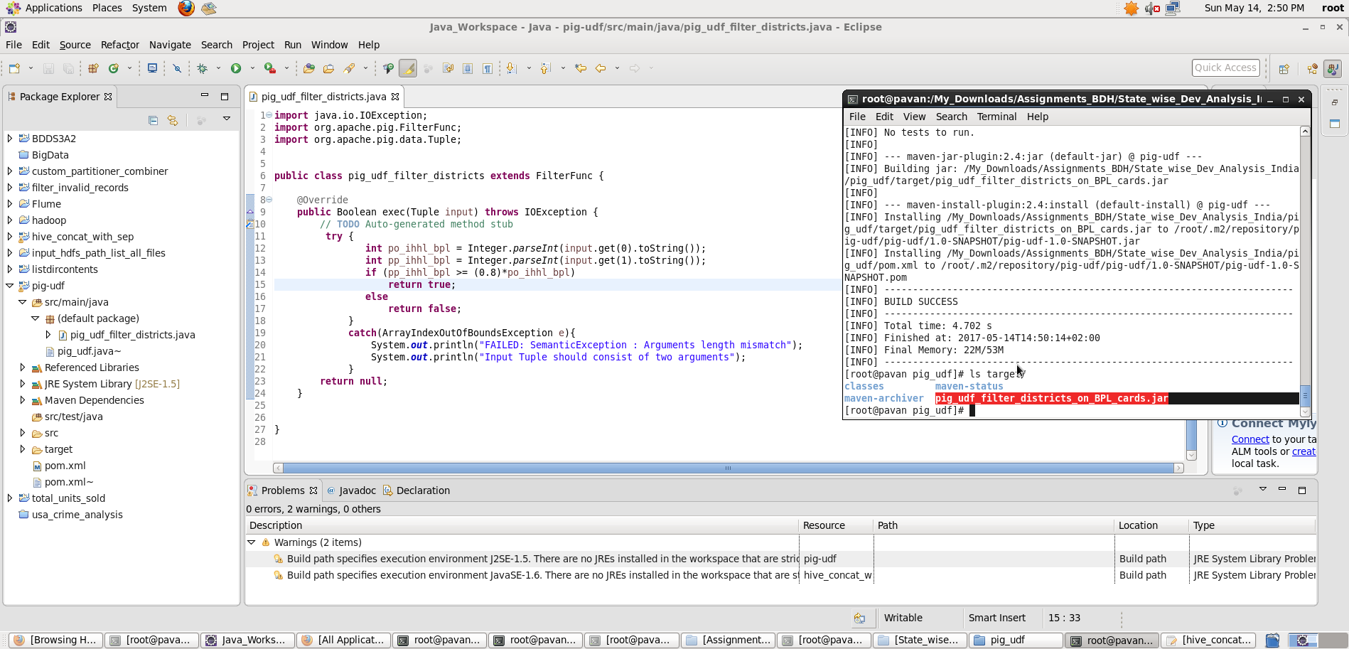

1. Now, simply, register the jar inside Pig Latin script and use the UDF with class name - **pig_udf_filter_districts**

and **pass the required arguments** as follows:

**Pig Latin Script:**

register ./pig_udf/target/pig_udf_filter_districts_on_BPL_cards.jar;

register '/usr/lib/pig/piggybank.jar';

xmldata_from_hdfs = LOAD 'hdfs://pavan:8020/tmp/State_wise_Dev_Analysis_India/flume_import/' using org.apache.pig.piggybank.storage.XMLLoader('row') as (doc:chararray);

xmldata_parsed = foreach xmldata_from_hdfs GENERATE FLATTEN(REGEX_EXTRACT_ALL(doc,'<row>\\s*<State_Name>(.*)</State_Name>\\s*<District_Name>(.*)</District_Name>\\s*<Project_Objectives_IHHL_BPL>(.*)</Project_Objectives_IHHL_BPL>\\s*<Project_Objectives_IHHL_APL>(.*)</Project_Objectives_IHHL_APL>\\s*<Project_Objectives_IHHL_TOTAL>(.*)</Project_Objectives_IHHL_TOTAL>\\s*<Project_Objectives_SCW>(.*)</Project_Objectives_SCW>\\s*<Project_Objectives_School_Toilets>(.*)</Project_Objectives_School_Toilets>\\s*<Project_Objectives_Anganwadi_Toilets>(.*)</Project_Objectives_Anganwadi_Toilets>\\s*<Project_Objectives_RSM>(.*)</Project_Objectives_RSM>\\s*<Project_Objectives_PC>(.*)</Project_Objectives_PC>\\s*<Project_Performance-IHHL_BPL>(.*)</Project_Performance-IHHL_BPL>\\s*<Project_Performance-IHHL_APL>(.*)</Project_Performance-IHHL_APL>\\s*<Project_Performance-IHHL_TOTAL>(.*)</Project_Performance-IHHL_TOTAL>\\s*<Project_Performance-SCW>(.*)</Project_Performance-SCW>\\s*<Project_Performance-School_Toilets>(.*)</Project_Performance-School_Toilets>\\s*<Project_Performance-Anganwadi_Toilets>(.*)</Project_Performance-Anganwadi_Toilets>\\s*<Project_Performance-RSM>(.*)</Project_Performance-RSM>\\s*<Project_Performance-PC>(.*)</Project_Performance-PC>\\s*</row>')) AS (state_name:chararray, district_name:chararray, po_ihhl_bpl:int, po_ihhl_apl:int, po_ihhl_total:int, po_scw:int, po_sch_toilets:int, po_angan_toilets:int, po_rsm:int, po_pc:int, pp_ihhl_bpl:int, pp_ihhl_apl:int, pp_ihhl_total:int, pp_scw:int, pp_sch_toilets:int, pp_angan_toilets:int, pp_rsm:int, pp_pc:int);

data_with_eighty_percent_bpl_cards = filter xmldata_parsed by pig_udf_filter_districts(po_ihhl_bpl,pp_ihhl_bpl);

districts_with_eighty_percent_bpl_cards = foreach data_with_eighty_percent_bpl_cards generate district_name,po_ihhl_bpl,pp_ihhl_bpl;

--dump districts_with_eighty_percent_bpl_cards;

store districts_with_eighty_percent_bpl_cards into 'hdfs://pavan:8020/tmp/project_2/state_wise_dev_analysis_results_task_b' using PigStorage(',');

**Explanation :**

* Loaded data from HDFS directory location: **'hdfs://pavan:8020/tmp/State_wise_Dev_Analysis_India/flume_import/'** into “xmldata_from_hdfs” relation using XMLLoader and schema is provided accordingly.

**Note: In order to load the XML data into the Pig structures, one needs to parse the XML so that Pig can understand it. Thus we shall use the XMLLoader() function which is present in PiggyBank of Apache. PiggyBank is a repository of Java user defined functions.**

* Then, all records are filtered with the help of Pig UDF (that we have created previously)
* Now, foreach data_with_eighty_percent_bpl_cards , I have generated the district_name, po_ihhl_bpl and pp_ihhl_bpl records.
* **Storing the result relation into a HDFS directory** 'hdfs://pavan:8020/tmp/project_2/state_wise_dev_analysis_results_task_b’**.**

Screenshots

Running **Pig Latin Script in Local Mode** inside /My_Downloads/Assignments_BDH/State_wise_Dev_Analysis_India/ directory

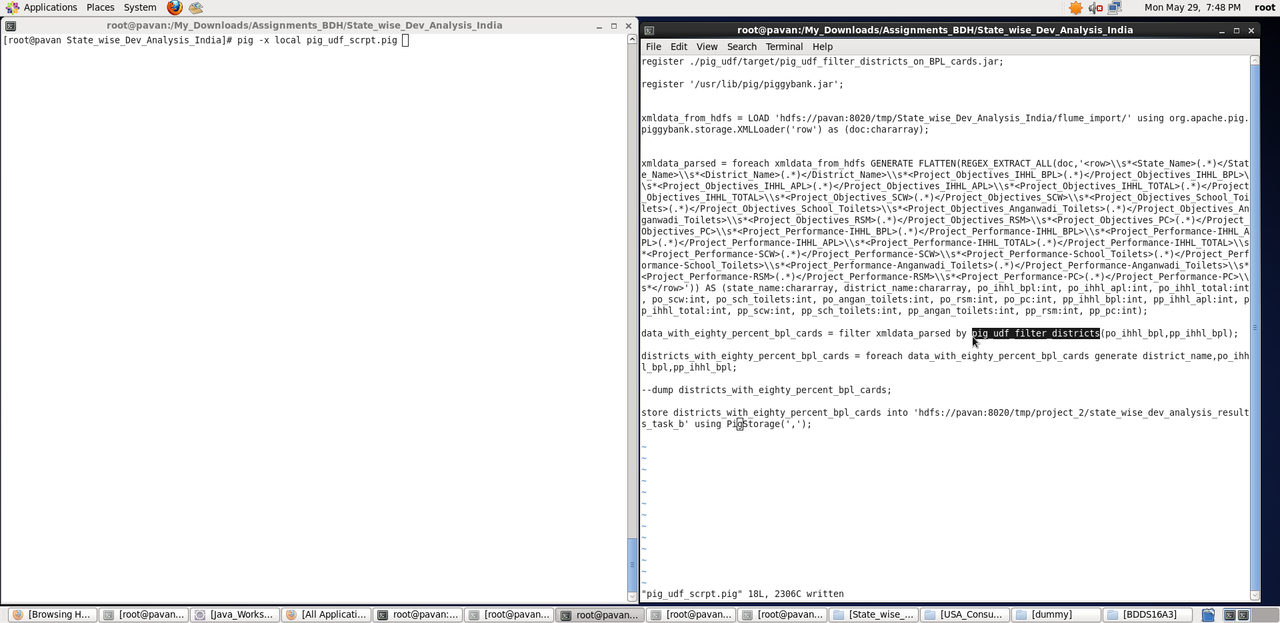

**Output stored in the format**: **<District_Name>,<po_ihhl_bpl>,<pp_ihhl_bpl>**

**We can see the output stored in the specified HDFS directory as below:**

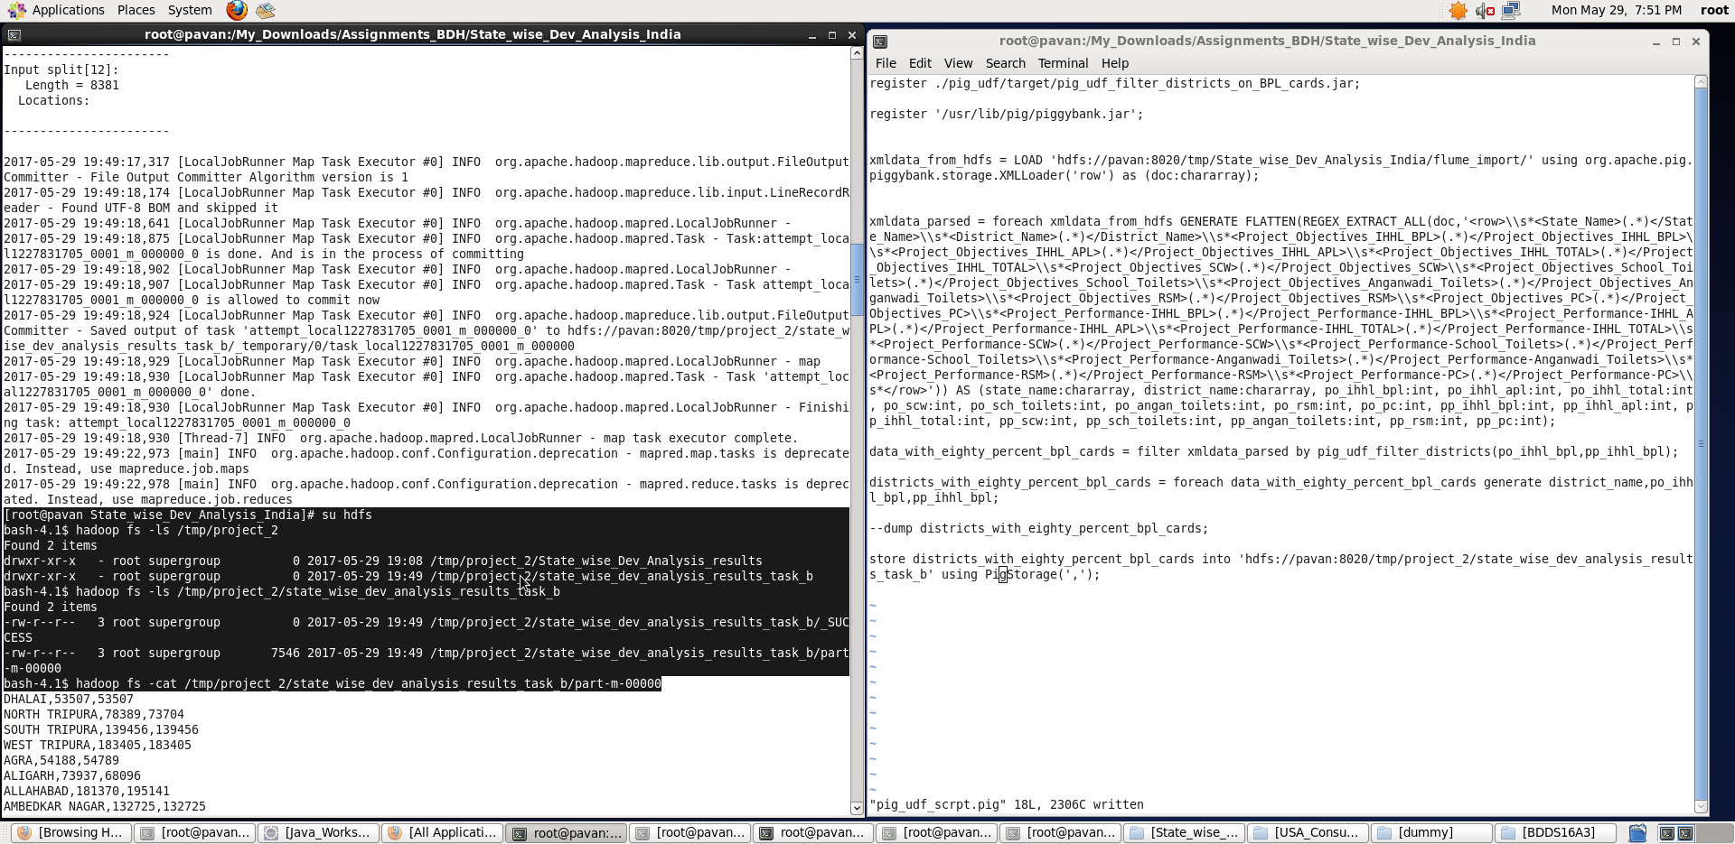

**Export the results to mysql using sqoop.**

**For this, the table should be already present in mysql before we export the result from HDFS**

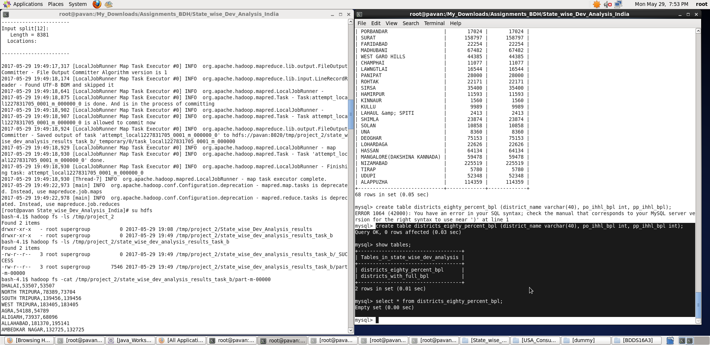

**Once, the table is created, use the sqoop export command as shown below to export the results into mysql.**

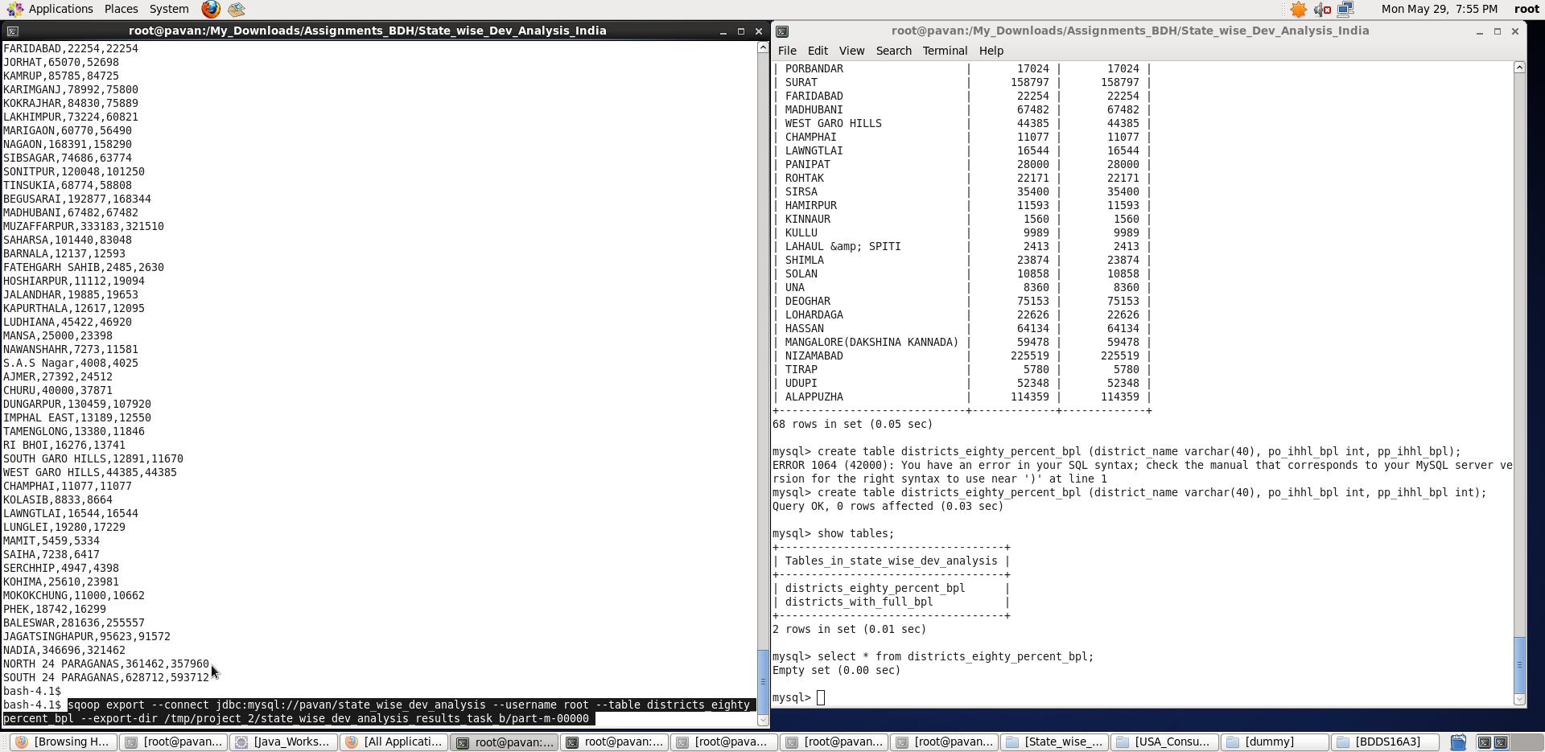

**Once, the export is done, we can see results getting stored in the districts_with_eighty_percent_bpl table inside state_wise_dev_analysis database using “*select * from districts_with_eighty_percent_bpl”* command.**

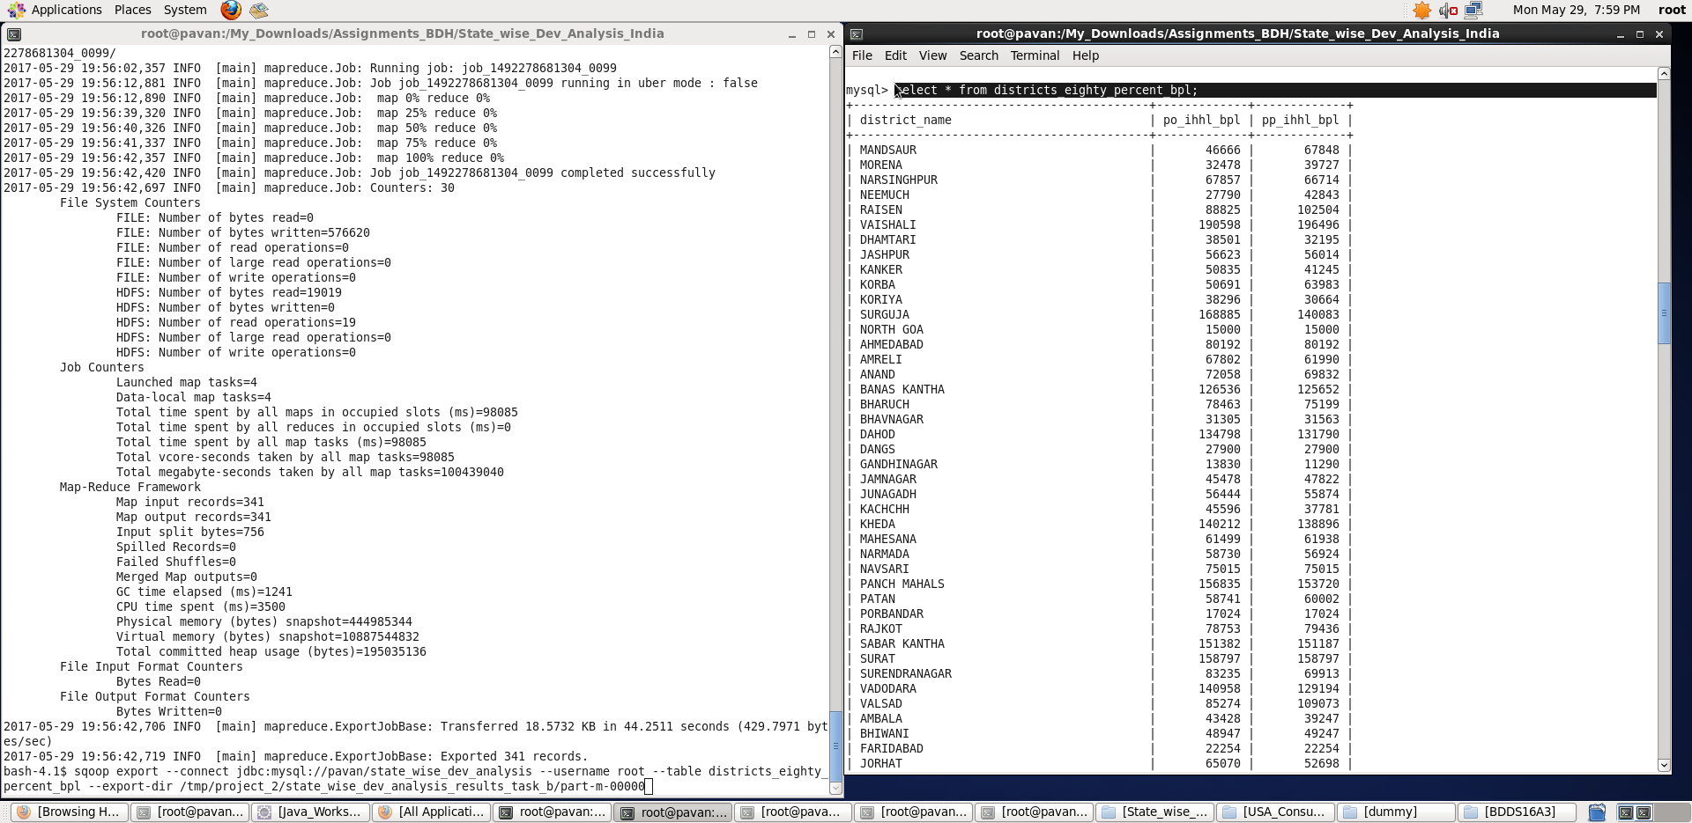

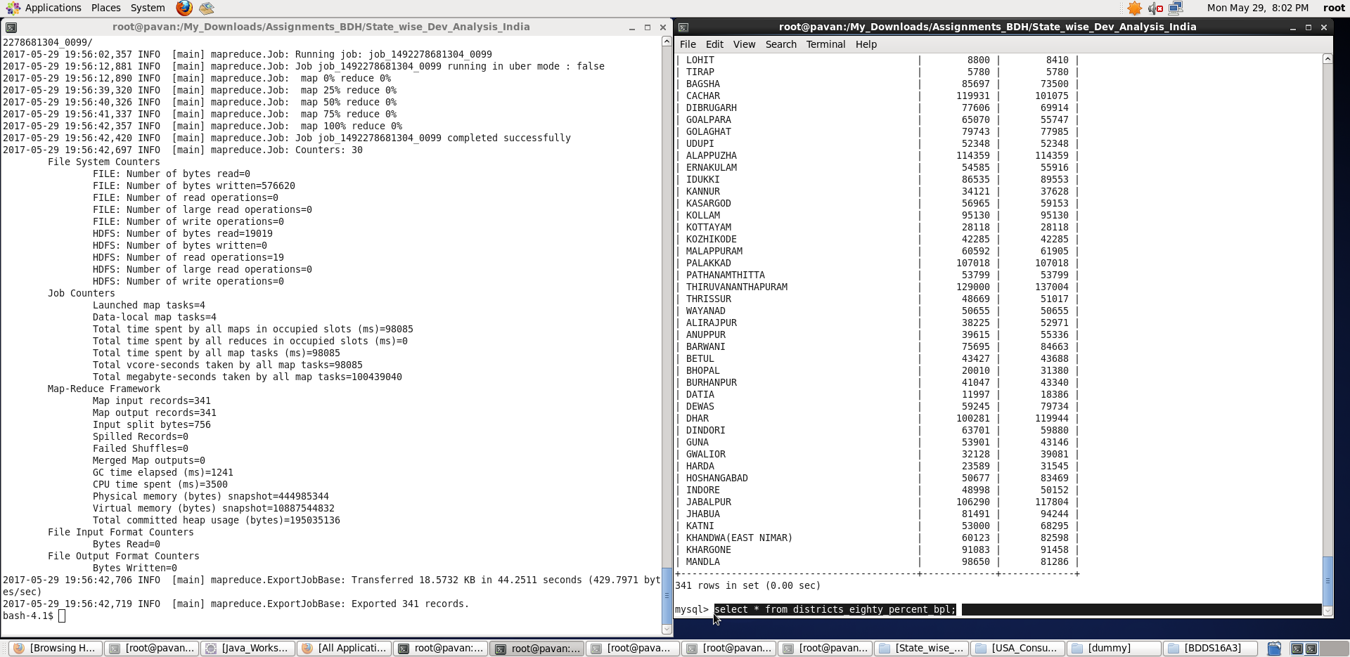

**Thus, we found the districts who have reached 80 percent objective in BPL cards and exported the results to mysql using sqoop.**

**Note: I have considered more than 80 percent objective achievement in BPL cards.**